**Jesus has forgiven my sins**

**Reading: Romans 3:22-25**

We are made right with God by putting our faith in Jesus Christ. This happens to all who believe. It is no different for the Jews than for the Gentiles. Everyone has sinned. No-one measures up to God’s glory. The free gift of God’s grace makes us right with him. Christ Jesus has paid the price to set us free. God forgives the sins of those who have faith.

**Thought about the reading**

What is sin? It is more than just the things we sometimes do wrong. Sin is not believing God. God tells us what we should do to live, but we choose to go our own way. We don’t believe what God tells us.

At the beginning of the Bible, there is a story about Adam and Eve. They were the first two people that God created. They lived in a beautiful garden and were very happy. God told them they could eat any of the fruit on the trees, except one tree. If they ate from that tree, they would die.

The snake told them that they would not die. They believed the snake. They did not believe God. They thought the fruit looked good and they ate some. They disobeyed God.

When we sin like this, our relationship with God is broken. Adam and Eve were thrown out of the beautiful garden where they used to meet with God. Because of sin our relationships with each other are also broken, and so hate, murder and death come into the world. This is the price of sin.

Our reading says that everyone has sinned. We all choose to go our own way and ignore God. We all have to pay the price.

But God loves us and so he sent his Son Jesus to deal with our sin. Jesus was perfect. He never did anything wrong. So, he was the perfect person who could pay the price for all the sin in the world. He did this by dying on a cross. Because he did this, God will forgive our sin. We can be friends with God again.

We need to recognise that we have all done wrong. Then if we are sorry and we believe that Jesus paid the price for us when he died on the cross, God will forgive us.

**Prayer**

Dear Jesus, I know that I like to go my own way. I don’t listen to God or believe what he says. I am truly sorry.

I believe that you died so that I could be forgiven. Please forgive me. Please help me to follow you.

Amen

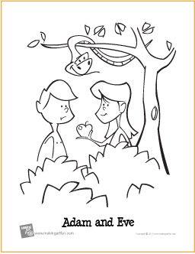

**Cambridge Causeway**

Autumn 2024

Bible Study notes

**What Jesus has done for me**

1. **Jesus has forgiven my sins**

By Chrissy Cole